**Database Management System – Phase 1**

**SID**: 202005204 **STUDENT NAME:** Salma Eletreby **Email**: Se2005204@qu.edu.qa

**SID**: 202003532 **STUDENT NAME:** Aya Muhanad Hassan **Email**: ah2003532@qu.edu.qa

**SID**: 202001942 **STUDENT NAME:** Hissa Al Muhannadi **Email**: ha2001942@qu.edu.qa

**Course number**: CMPS 451

**Submission date**: 24th October 2023

**Class section:** L51

Table of Contents

Chosen ER diagram: University. 3

Schema 4

SQL Commands: 5

SQL tables Description: 9

College 9

Instructor 9

Department 9

Student 10

Course 10

Student_Section 11

SQL Insert Statements: 12

SQL Populated Tables: 15

College 15

Course 15

Department 15

Instructor 15

Section 15

Student 16

Student_Section 16

# Chosen ER diagram: University.

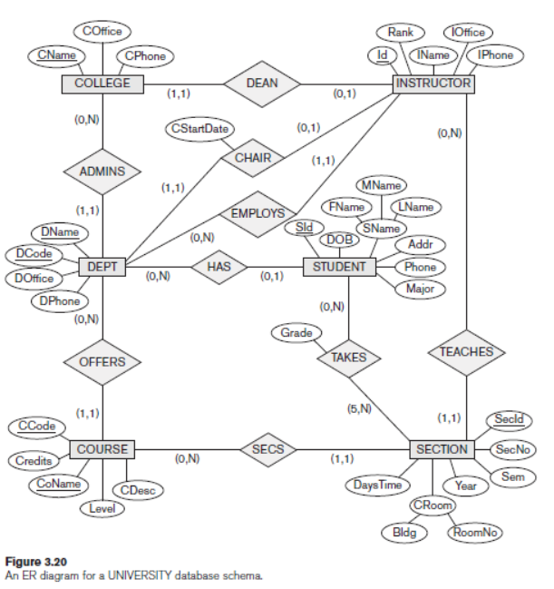

Schema:

Legend:

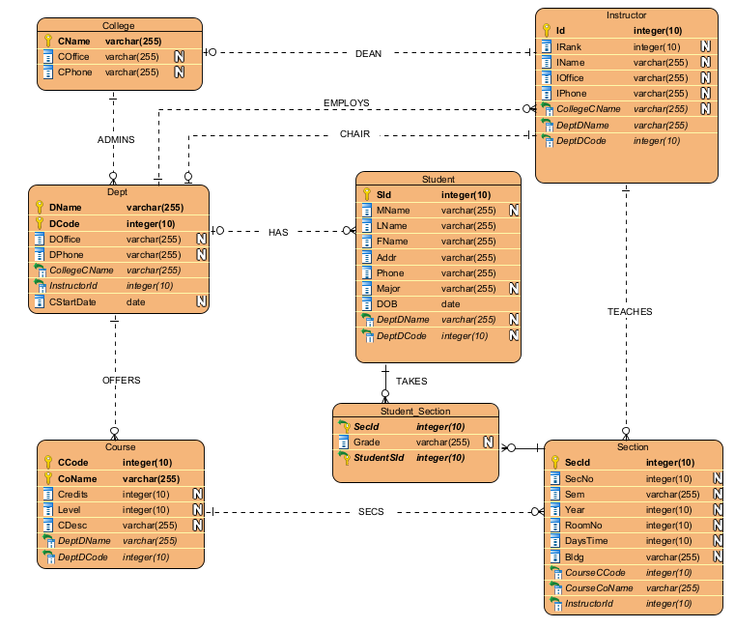

# SQL Commands:

CREATE TABLE College (

CName VARCHAR(255) PRIMARY KEY,

COffice VARCHAR(255) ,

CPhone VARCHAR(255)

)

CREATE TABLE Dept (

DName VARCHAR(255),

DCode Integer(10) ,

DOffice VARCHAR(255) ,

DPhone VARCHAR(255) ,

CStartDate date NOT NULL,

CollegeCName VARCHAR(255) NOT NULL ,

FOREIGN KEY (CollegeCName) REFERENCES College(CName),

PRIMARY KEY (DName, DCode)

)

CREATE TABLE Course (

CCode Integer,

CoName VARCHAR(255) ,

Credits Integer,

Level Integer,

CDesc VARCHAR(255),

DeptDName VARCHAR(255) NOT NULL,

DeptDCode integer NOT NULL,

FOREIGN KEY (DeptDName,DeptDCode) REFERENCES Dept(DName,DCode),

PRIMARY KEY (CCode, CoName)

)

CREATE TABLE Student (

SId Integer PRIMARY KEY,

MName VARCHAR(255) ,

FName VARCHAR(255) ,

LName VARCHAR(255) ,

Addr VARCHAR(255) ,

Phone VARCHAR(255) ,

Major VARCHAR(255) ,

DOB date,

DeptDName VARCHAR(255) ,

DeptDCode integer,

FOREIGN KEY (DeptDName,DeptDCode) REFERENCES Dept(DName,DCode)

)

CREATE TABLE Instructor (

Id Integer PRIMARY KEY,

IRank integer ,

IName VARCHAR(255) ,

IPhone VARCHAR(255) ,

IOfficee VARCHAR(255) ,

CollegeCname VARCHAR(255) ,

DeptDCode integer NOT NULL,

DeptDName VARCHAR(255) NOT NULL ,

FOREIGN KEY (DeptDName,DeptDCode) REFERENCES Dept(DName,DCode),

FOREIGN KEY (CollegeCname) REFERENCES College(CName)

)

CREATE TABLE Section (

SecId Integer PRIMARY KEY,

SecNo integer ,

Sem VARCHAR(255) ,

Year integer,

RoomNo integer,

DaysTime integer,

Bldg VARCHAR(255),

CourseCCode integer NOT NULL,

CourseCoName VARCHAR(255) NOT NULL,

InstructorId integer NOT NULL,

FOREIGN KEY (CourseCCode,CourseCoName) REFERENCES Course(CCode,CoName),

FOREIGN KEY (InstructorId) REFERENCES Instructor(Id)

)

CREATE TABLE Student_Section (

SecId Integer ,

Grade VARCHAR(255),

StudentStd integer ,

primary key(SecId,StudentStd),

FOREIGN KEY (SecId) REFERENCES Section(SecId),

FOREIGN KEY (StudentStd) REFERENCES Student(SId)

)

ALTER TABLE Dept

ADD COLUMN InstructorId integer;

ALTER TABLE Dept

ADD CONSTRAINT

FOREIGN KEY (InstructorId)

REFERENCES Instructor (Id);

# SQL tables Description:

## College

## Instructor

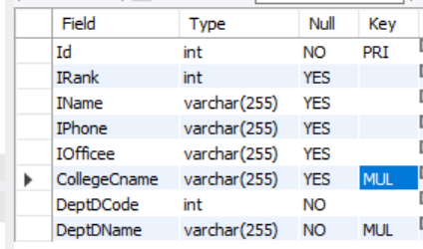

## Department

## Student

## Course

Section

## Student_Section

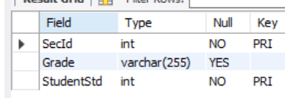

# SQL Insert Statements:

USE Project;

INSERT INTO College VALUES ('Liberal Arts College','123 Main Street Suite 400','(666) 123-4567');

INSERT INTO College VALUES ('Health and Wellness College','567 Wellness Center Suite 33','(666) 123-4567');

INSERT INTO College VALUES ('College of Engineering','789 Engineering Avenue Room 101' ,'(666) 123-4567');

INSERT INTO College VALUES('Business College','321 Commerce Plaza Office 210','(666) 123-4567');

INSERT INTO College VALUES('Music Academy College','Melody Lane Office 300','(666) 123-4567');

_____________________________________________________________________________________

INSERT INTO Dept (DName, DCode, DOffice, DPhone, CStartDate, CollegeCName,InstructorId) VALUES ('Art', 300, 'Arts Building, Room 300', '(555) 555-1234', '1888-08-10', 'Liberal Arts College',null);

INSERT INTO Dept VALUES ('Nursing', 100, 'Health Building, Suite 33', '(666) 321-6789', '1890-09-05', 'Health and Wellness College',null);

INSERT INTO Dept VALUES ('Computer Science', 200, 'Engineering Building, Room 203', '(555) 123-4567', '1990-01-01', 'College of Engineering',null);

INSERT INTO Dept VALUES('Business Administration', 400, 'Business Building, Office 301', '(555) 123-4567', '2023-08-25', 'Business College',null);

INSERT INTO Dept VALUES('Computer Engineering', 500, 'Engineering Building Room 204', '(555) 123-4567', '1990-01-01', 'College of Engineering', null);

INSERT INTO Dept VALUES('Instrumental Department', 600, 'Musical Building, Room 204', '(555) 123-4567', '1990-01-01', 'Music Academy College', null);

_____________________________________________________________________________

INSERT INTO Instructor (Id ,IRank ,IName ,IPhone ,IOfficee ,CollegeCname ,DeptDCode ,DeptDName )

VALUES(1,1,'Omar Ahmed','(999) 4444 1234','(666) 123-4567','College of Engineering',200,'Computer Science');

INSERT INTO Instructor VALUES(2,2,'Noora Mohammed','(999) 4444 1234','(666) 123-4567','Health and Wellness College',100,'Nursing');

INSERT INTO Instructor VALUES(3,3,'Saad Abdulla','(999) 4444 1234','(666) 123-4567','Liberal Arts College',300,'Art');

INSERT INTO Instructor VALUES(4, 4, 'Mariam Nasser', '(999) 4444 1234', '(666) 123-4567', 'College of Engineering', 500, 'Computer Engineering');

INSERT INTO Instructor VALUES(5, 4, 'Noor Kareem', '(999) 4444 1234', '(666) 123-4567', 'Music Academy College', 600, 'Instrumental Department');

_____________________________________________________________________________________

UPDATE Dept SET InstructorId = 1 WHERE DCode = 300 LIMIT 1;

UPDATE Dept SET InstructorId = 3 WHERE DCode = 200 LIMIT 1;

UPDATE Dept SET InstructorId = 2 WHERE DCode = 100 LIMIT 1;

UPDATE Dept SET InstructorId = 4 WHERE DCode = 500 LIMIT 1;

UPDATE Dept SET InstructorId = 5 WHERE DCode = 600 LIMIT 1;

__________________________________________________________________________________

INSERT INTO Course VALUES (255,'OOP',3,1,'OOP is a programming paradigm that is widely used in software development','Computer Science',200);

INSERT INTO Course VALUES (355,'Art History',3,2,'focuses on the history of art, art movements, and the critical analysis of art','Art',300);

INSERT INTO Course VALUES (155,'Public Health',3,1,'related to public health principles, epidemiology, health policy, and disease prevention','Nursing',100);

INSERT INTO Course VALUES(119,'Programming Concepts',3,1, 'Programming Concepts course is a foundation for programming', 'Computer Engineering',500);

INSERT INTO Course VALUES(455,' Marketing and Sales',3,4,'marketing strategies, market research, product development, branding', 'Business Administration',400);

_____________________________________________________________________________________

INSERT INTO Student (SId ,MName,FName ,LName ,Phone ,Major ,DOB ,DeptDName ,DeptDCode )

VALUES (1,'Abdullah','Hissa','AL Muhannadi','(666) 123-4567','Computer Science','2001-12-02','Computer Science',200);

INSERT INTO Student (SId ,MName,FName ,LName ,Phone ,Major ,DOB ,DeptDName ,DeptDCode )

VALUES (2,'Muhanad','Aya ','Hassan','(666) 123-4567','Computer Science','2001-04-01','Computer Science',200);

INSERT INTO Student (SId ,MName,FName ,LName ,Phone ,Major ,DOB ,DeptDName ,DeptDCode )

VALUES (3,'Shady','Salma','Eletreby','(666) 123-4567','Computer Science','2000-06-01','Computer Science',200);

INSERT INTO Student (SId ,MName,FName ,LName ,Phone ,Major ,DOB ,DeptDName ,DeptDCode )

VALUES (4,'Ahmed','Asma','Al Mannai','(666) 123-4567','Medical-Surgical Nursing','1999-07-01','Nursing',100);

INSERT INTO Student (SId ,MName,FName ,LName ,Phone ,Major ,DOB ,DeptDName ,DeptDCode )

VALUES (5,'Abdullah','Shiekha','Al kuwari','(666) 123-4567','Fine Arts','1998-09-14','Art',300);

_____________________________________________________________________________________

INSERT INTO Section (SecId ,SecNo ,Sem ,Year ,RoomNo ,DaysTime ,Bldg ,CourseCCode ,CourseCoName,InstructorId )

VALUES(10, 101, 'Fall', 2023, 203, 101, 'Science Hall', 155, 'Public Health', 2);

INSERT INTO Section VALUES(20, 201, 'Spring', 2023, 305, 100, 'Engineering Hall', 255, 'OOP', 1);

INSERT INTO Section VALUES(30, 301, 'Fall', 2022, 405, 99, 'Art Hall', 355, 'Art History', 3);

INSERT INTO Section VALUES(40, 401, 'Spring', 2022, 405, 100, 'Engineering Hall', 119, 'Programming Concepts', 4);

INSERT INTO Section VALUES(50, 501, 'Spring', 2023, 505, 100, 'Engineering Hall', 255, 'OOP', 4);

_____________________________________________________________________________________

INSERT INTO Student_Section (SecId ,Grade ,StudentStd) VALUES(10,A,4);

INSERT INTO Student_Section VALUES(20,C,1);

INSERT INTO Student_Section VALUES(30,B,5);

INSERT INTO Student_Section VALUES(40,D,2);

INSERT INTO Student_Section VALUES(50,B,3);

# SQL Populated Tables:

## College

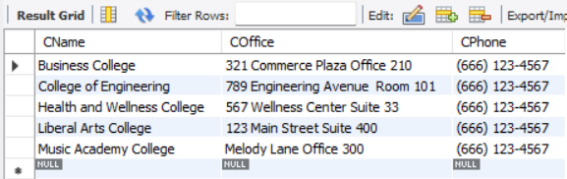

## Course

## Department

## Instructor

## Section

## Student

## Student_Section

